tf.R

sumedh

Tue Oct 09 14:06:21 2018

setwd("C:/Users/sumedh/Desktop/assignment")  
wtdata=read.csv("wt_data.csv")  
wtdata=na.omit(wtdata)  
library(MASS)  
library(tidyverse)

## Warning: package 'tidyverse' was built under R version 3.5.1

## -- Attaching packages ---------------------------------- tidyverse 1.2.1 --

## v ggplot2 2.2.1 v purrr 0.2.5  
## v tibble 1.4.2 v dplyr 0.7.5  
## v tidyr 0.8.1 v stringr 1.3.1  
## v readr 1.1.1 v forcats 0.3.0

## -- Conflicts ------------------------------------- tidyverse_conflicts() --  
## x dplyr::filter() masks stats::filter()  
## x dplyr::lag() masks stats::lag()  
## x dplyr::select() masks MASS::select()

library(knitr)

## Warning: package 'knitr' was built under R version 3.5.1

library(viridis)

## Loading required package: viridisLite

library(lubridate)

##   
## Attaching package: 'lubridate'

## The following object is masked from 'package:base':  
##   
## date

wtdata<-mutate(wtdata,ws_norm=windspeed/max(windspeed))  
wtdata$ttimestamplocal=dmy_hm(wtdata$ttimestamplocal)  
wtdata$year=year(wtdata$ttimestamplocal)  
wtdata$month=month(wtdata$ttimestamplocal)  
wtdata$day=day(wtdata$ttimestamplocal)  
yr=wtdata$year  
mth=wtdata$month  
dy=wtdata$day  
windspeed=wtdata$windspeed  
ws_norm=wtdata$ws_norm  
tf=data.frame(yr,mth,dy,windspeed,ws_norm)  
View(tf)  
library(imputeTS)  
library(fpp2)

## Loading required package: forecast

## Warning: package 'forecast' was built under R version 3.5.1

## Loading required package: fma

##   
## Attaching package: 'fma'

## The following objects are masked from 'package:MASS':  
##   
## cement, housing, petrol

## Loading required package: expsmooth

library(forecast)  
  
windspeed_d <- ts(tf[,4], start=c(2013,6), end=c(2014,1), frequency=31)  
plot(windspeed_d)

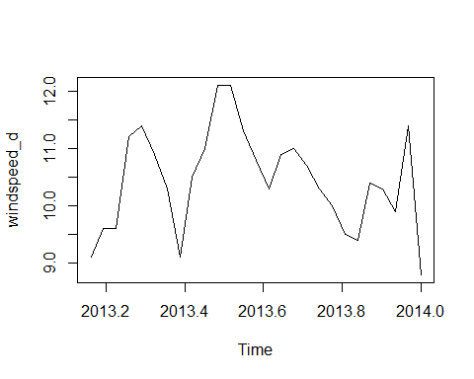

ws_norm_d <- ts(tf[,5], start=c(2013,6), end=c(2014,1), frequency=31)  
plot(ws_norm_d)

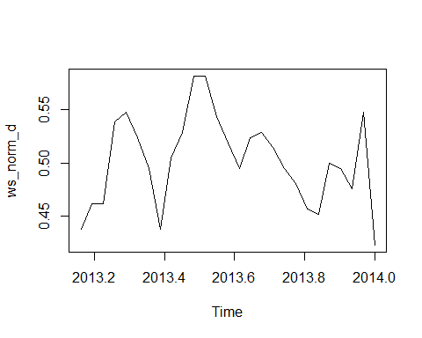

Acf(windspeed_d)

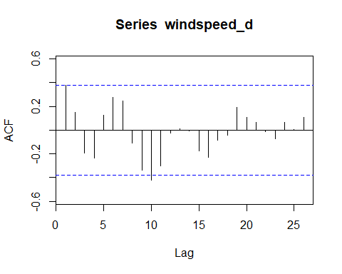

Acf(ws_norm_d)

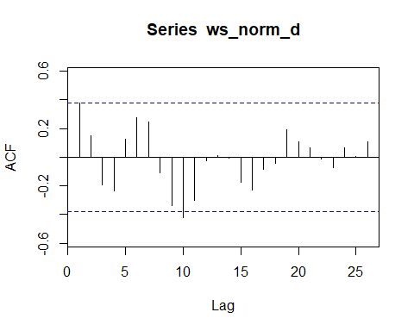

Pacf(windspeed_d)

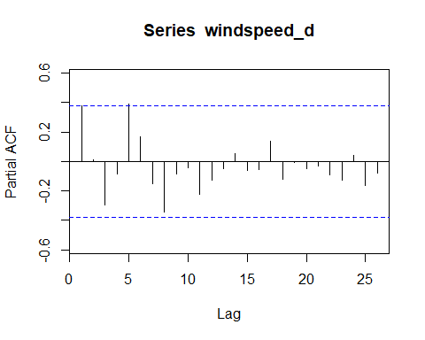

Pacf(ws_norm_d)

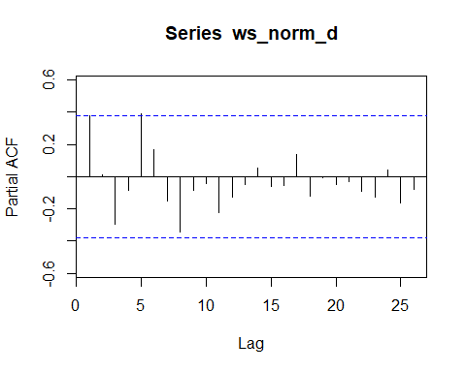

windspeed_w <- ts(tf[,4], start=c(2013,6), end=c(2014,1), frequency=7)  
plot(windspeed_w)

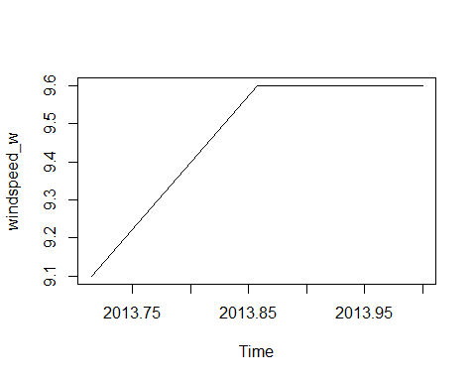

ws_norm_w <- ts(tf[,5], start=c(2013,6), end=c(2014,1), frequency=7)  
plot(ws_norm_w)

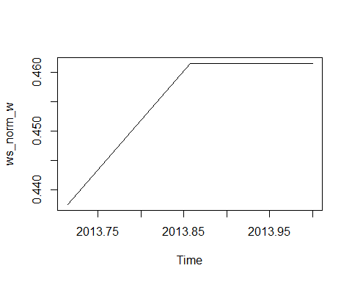

Acf(windspeed_w)

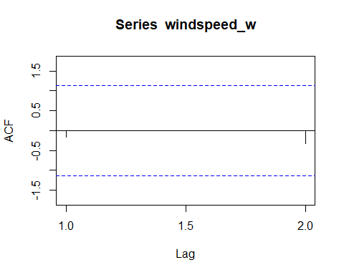

Acf(ws_norm_w)

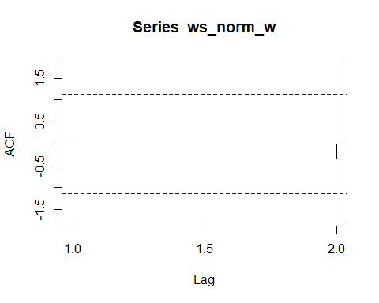

Pacf(windspeed_w)

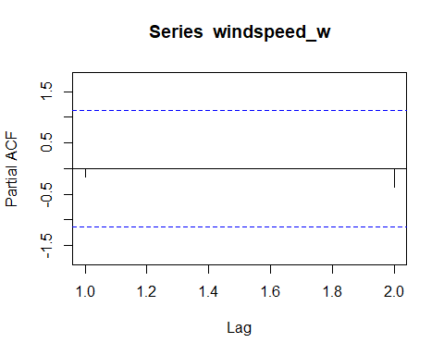

Pacf(ws_norm_w)

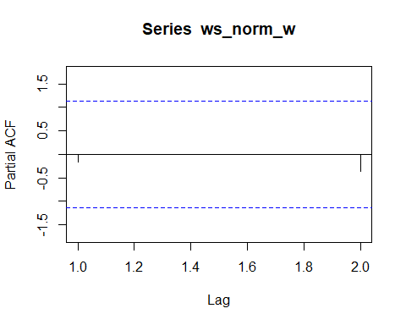

windspeed_m <- ts(tf[,4], start=c(2013,6), end=c(2014,1), frequency=12)  
plot(windspeed_m)

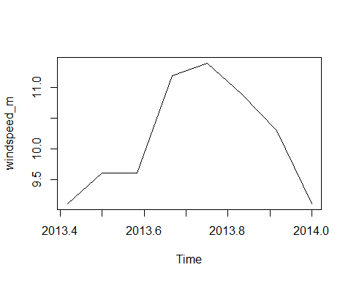

ws_norm_m <- ts(tf[,5], start=c(2013,6), end=c(2014,1), frequency=12)  
plot(ws_norm_m)

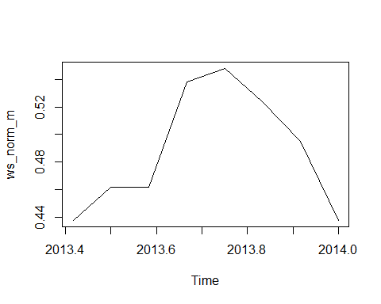

Acf(windspeed_m)

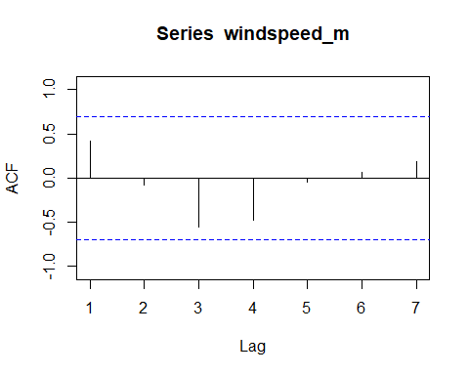

Acf(ws_norm_m)

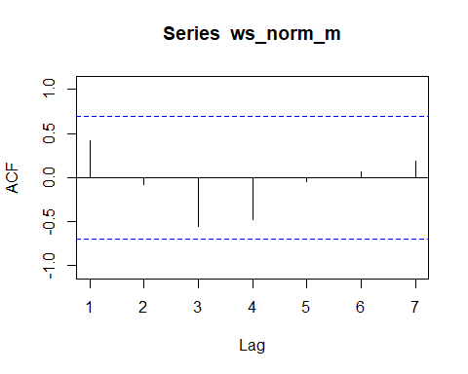

Pacf(windspeed_m)

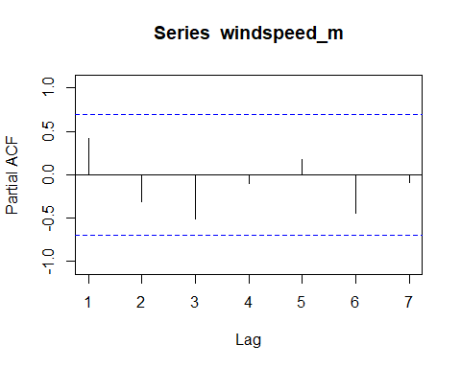

Pacf(ws_norm_m)

